Queues

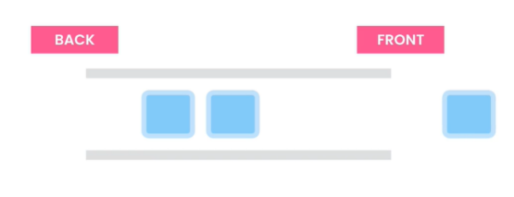V-(1+2)-Introduction to Queue:- (Just Like Stack but (FIFO))

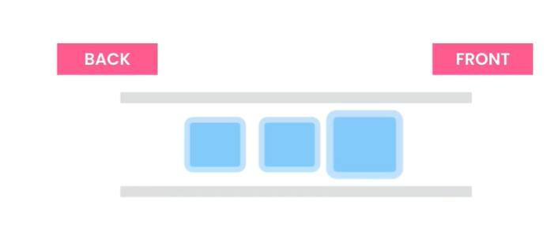

**1st item**

**1st item**

FIFO (First in First Out):- The basic difference between stack and queue is that. Stack = LIFO but Queue = FIFO.

The picture above clearly stated that the item that first inserted in the queue will remove first from the queue.



**Real Example**

**Of Queue**

More RealLife Example:-

1. Printer : Use queue cause the first file that is selected for printing will be printed first.

2. Operation System: Use queue for processes as there are many CPU scheduling Algorithms (FCFS,Round Robin,SRTF,Priority) to optimize the time and space .

3. Web Servers: Use queue to manage incoming requests.

4. Live Supports System: In Live Support systems for managing customers they serve per customer requests (Serially).

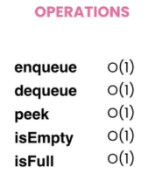

**Removing items from the front of the queue**

**Adding items at the back of the queue**

**Checking if queue is full or not**

**Checking if queue is empty or not**

**Getting items from the front of the queue without removing**

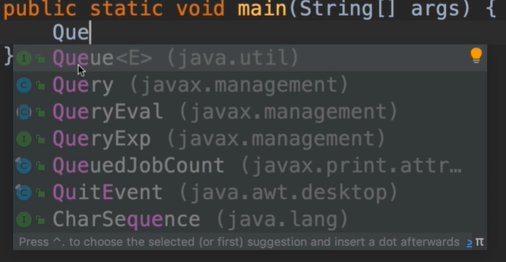

Its an interface. that means we can’t instantiate Queue Object .

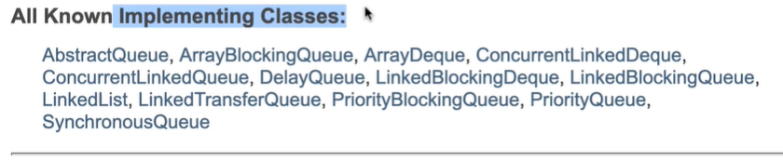

We see that many classes implemented Queue Interface. Among them 90% of our time we will use ArrayDeque and LinkedList Classes. In ArrayDeque class it has two ends (Front and Back).

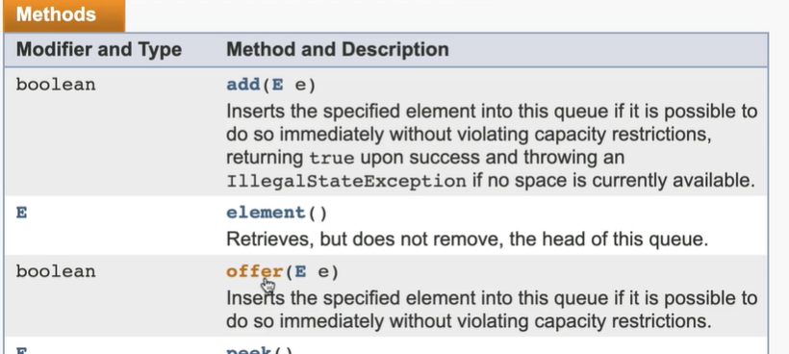

**Queue Full then**

**Don’t take that value.**

**Queue Full then throw exception**

**enque**

**enque**

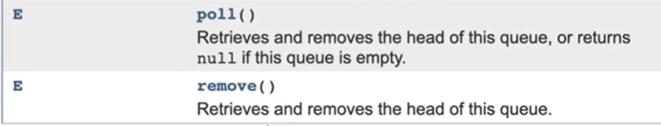

**No Exception occur,**

**Just return null if queue is empty.**

**Exception thrown for empty queue**

Queue Implementation(V-3):-

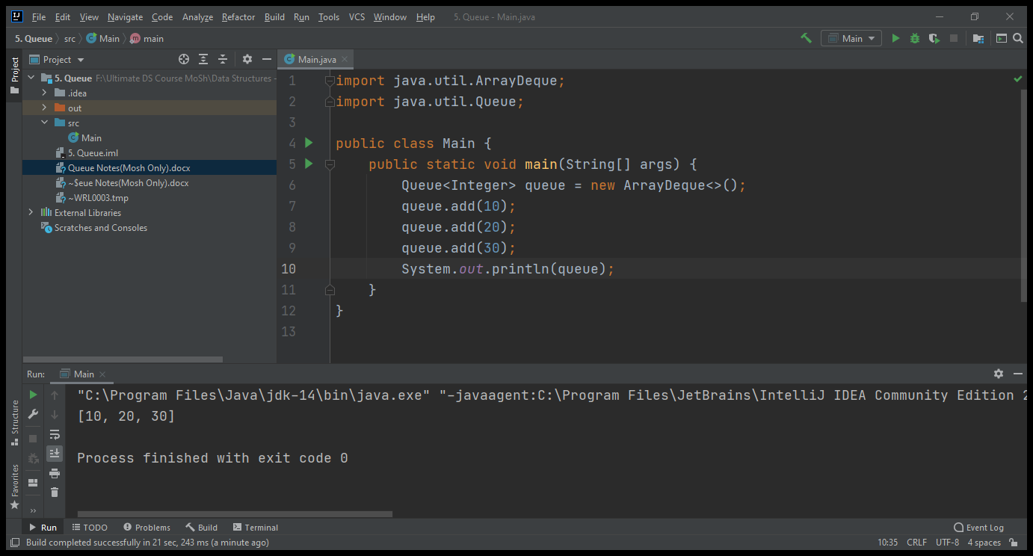

**Use ArrayDeque(Double+Queue) Class for Implement Queue**

Back/Rear

Front.

Queue<Integer> queue = new ArrayDeque<>();  
queue.add(10);// [10]  
queue.add(20);//[10,20]  
queue.add(30);//[10,20,30]  
System.*out*.println(queue);//[10,20,30]  
System.*out*.println(queue.remove());//10 cause 10 added first  
System.*out*.println(queue);//[20,30]

Output:-

[10, 20, 30]

10

[20, 30]

V-(4+5)-Reversing a queue:-(Use only add, remove ,isEmpty Method):-

public static void reverse(Queue<Integer> queue){  
 //add , remove an isEmpty methods to build this method  
 if(queue.isEmpty()) throw new IllegalArgumentException();  
 // Idea is that we use both stack and queue to implement this  
 // Queue = [10,20,30]  
 // Stack = []  
 //Now remove every items from queue and push to stack  
 // Then Stack = [10,20,30] and Queue = []  
 // Again pop every items from stack and enqueue it to the Queue  
 // Then it will like Stack = [],Queue = [30,20,10]  
 // We easily use stack to reverse anything cause it is LIFO structured  
 Stack<Integer> stack = new Stack<>();  
 while (!queue.isEmpty())  
 stack.push(queue.remove());  
 while (!stack.empty())  
 queue.add(stack.pop());  
  
}

V-(6+7+8)-Building a queue using an array.(But we should also know about building a queue using linkedlist and stack to pass any interview)

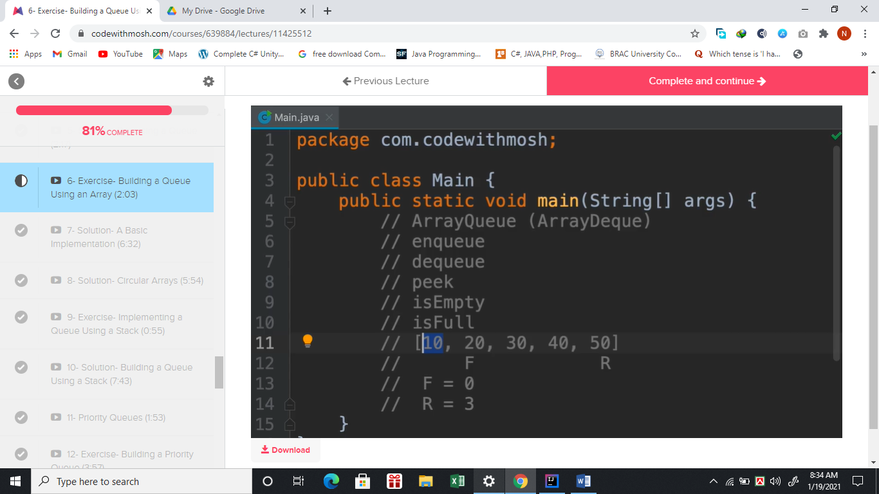

**Use Two Pointers**

**To implement**

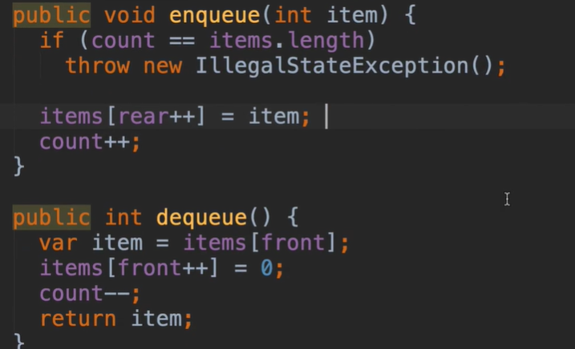

The Methods are not correct. Because rear will reach at the end of the array but we may have spaces left after dequeue. But once rear pointer will reach the end of the array it will give exception for next enqueue.



We already see that, our rear reference where every time new element is going to be inserted is now at the end index of the items array. So, though we dequeue 10 from the front and we should insert 1 new item in the items array. But when we try to do that it will give us and exception (ArrayIndexoutofBound). Which is not right . So we have to fixed this using circular array.



Correct way of enqueue and dequeue is given below(Using circular array):-

public void enqueue(int item){  
 //Here rear is needed because in rear the items inserted everytime  
 if(isFull()) throw new IllegalStateException();  
 queue[rear]=item;  
 rear=(rear+1)%queue.length;  
 count++;//it will help to count the items that is //inserted  
}  
public int dequeue(){  
 if(isEmpty()) throw new IllegalArgumentException();  
 var first = queue[front];  
 queue[front]=0;  
 front = (front+1)%queue.length;  
 count--;  
 return first;  
}

other supporting methods of implementation queue using an array:-

private boolean isEmpty(){  
 return count==0;//count 0 means no items is inserted  
}  
private boolean isFull(){  
 return count==queue.length;  
}

public int peek(){  
 if(isEmpty()) throw new IllegalStateException();  
 return queue[front];  
}  
@Override  
public String toString(){  
 return Arrays.*toString*(queue);  
}

The way of reftactoring method if same lines of logic use multiple times(same like field extracting):-

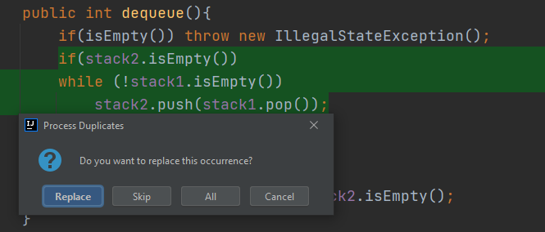

V-(9+10)-Build queue with Stack(ONLY):-

As stack is LIFO it is totally impossible to implement with one stack only. We have to use atleast two stacks.



import java.util.Stack;  
  
public class QueueWithTwoStacks {  
 // Popular Interview Question  
 // Here we have to build queue with stacks  
 // But there is a problem  
 // queue is FIFO and Stack is LIFO  
 // But we can use at least two Stacks to solve this problem  
 // One Stack will be dedicated for enqueue and other one is for dequeue  
 // suppose Q[10,20]  
 // S1 for enqueue S1 [10,20]  
 // S2 will store the value from S1 in reverse order that means we have to pop from S1  
 // S2 [20,10] now if we pop from S2 as dequeue then we get 10 which is like queue FIFO  
 // But there is a problem with dequeue  
 // if S2 pop 10 then S2 = [20] , Here if we enqueue 30 now in S1=[20,30] it will confused us where to add those and it will mess up the whole idea  
 // so we have to pop all items from S1 and push it to s2 then only it will be resolved  
 Stack<Integer> stack1 = new Stack<>();// for enqueue  
 Stack<Integer> stack2 = new Stack<>();// for dequeue  
 public void enqueue(int item){  
 stack1.push(item);// 0(1)  
 }  
 public int dequeue(){  
 if(isEmpty()) throw new IllegalStateException();  
 moveStack1toStack2();  
 return stack2.pop();  
 }  
 public boolean isEmpty(){  
 return stack1.isEmpty() && stack2.isEmpty();  
 }  
 public int peek(){  
 if(isEmpty()) throw new IllegalStateException();  
 moveStack1toStack2();  
 return stack2.peek();  
 }  
  
 private void moveStack1toStack2() {  
 if (stack2.isEmpty())  
 while (!stack1.isEmpty())  
 stack2.push(stack1.pop());  
 }  
  
  
}

V-11-(Priority Queues):-[By default we see that items removed from this priority queue hasn’t follow the traditional order, it is removed followed by ascending orders ].

This sort of implementation is needed when we have to prioritize something . For ex- If we have to give token to various types of patients[emergency,normal] in hospital we have to give token follow prioritizing. Then another example can be if we have received 100000 mail and we have to find the important mails as soon as possible then we can prioritize them.

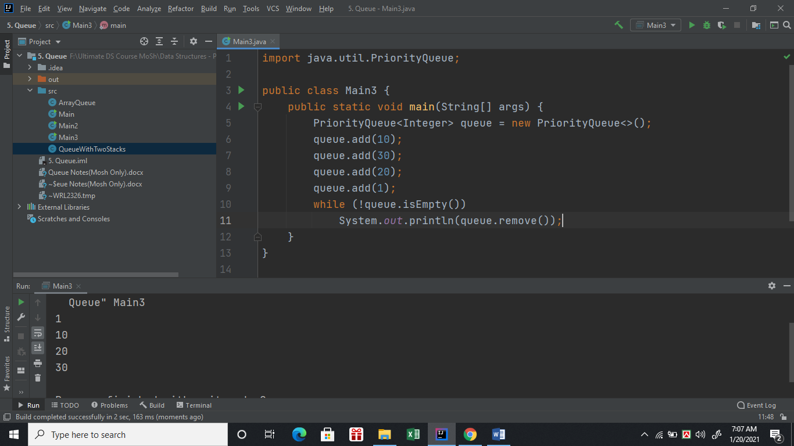

V-(12-14)-Building priority queues with array.[we can use heap also to implement that]

import java.util.Arrays;  
  
public class CustomPriorityQueue {  
 private int items[] = new int[5];  
 private int count;  
 public void add(int item){  
 // As we set the priority of smaller number to be inserted at the beginning  
 // [0,0,0,0,0] items  
 // add(5)  
 // add(1)  
 // add(3)  
 // the array should be [1,3,5,0,0]  
 // that means we have to iterate from the last item of the array  
 // if the item is less than the item exist in current index  
 // that means we have to do right shift and for not missing any value we shift values from end of the array  
 if(isFull())  
 throw new IllegalStateException();  
 var i = shiftItemsToInsert(item);  
 items[i+1]=item;  
 count++;  
 }  
 public boolean isFull(){  
 return count== items.length;  
 }  
 public int shiftItemsToInsert(int item){  
 int i;  
 for(i=count-1;i>=0;i--){  
 if(items[i]>item)  
 items[i+1]=items[i];//shifting items  
 else  
 break;  
 }  
 return i+1;  
 }  
 public boolean isEmpty(){  
 return count==0;  
 }  
 public int remove(){// considering highest number get the higher priority  
 if(isEmpty())  
 throw new IllegalStateException();  
 return items[--count];  
 }  
 @Override  
 public String toString(){  
 return Arrays.*toString*(items);  
 }  
  
}

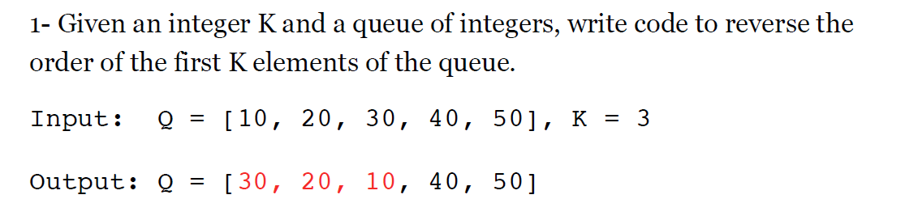Exercise Queue:-

Ex-1 Code answer:-

import java.util.Queue;

import java.util.Stack;

public class QueueReverser {

public static void reverse(Queue<Integer> queue, int k) {

if (k < 0 || k > queue.size())

throw new IllegalArgumentException();

java.util.Stack<Integer> stack = new Stack<>();

// Dequeue the first K elements from the queue

// and push them onto the stack

for (int i = 0; i < k; i++)

stack.push(queue.remove());

// Enqueue the content of the stack at the

// back of the queue

while (!stack.empty())

queue.add(stack.pop());

// Add the remaining items in the queue (items

// after the first K elements) to the back of the

// queue and remove them from the beginning of the queue

for (int i = 0; i < queue.size() - k; i++)

queue.add(queue.remove());

}

}

Simulation:-



Exercise -2:-

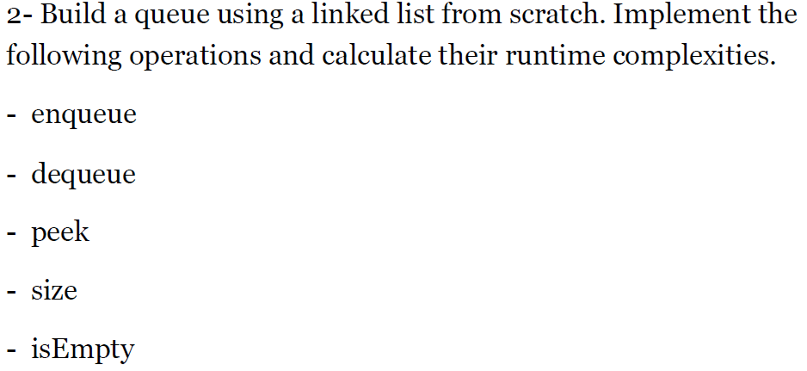

Ans:-

import java.util.ArrayList;  
  
public class LinkedListQueue {  
  
 private class Node{  
 private Node next;  
 private int value;  
 public Node(int value){  
 this.value=value;  
 }  
 }  
 private Node head;  
 private Node tail;  
 private int count;  
 //O(1)  
 public void enqueue(int value){  
 Node NewNode = new Node(value);  
 if(isEmpty()){  
 head=tail=NewNode;  
 }  
 else{  
 tail.next=NewNode;  
 tail = NewNode;  
 }  
 count++;  
 }

//O(1)  
 public int dequeue(){  
 if(isEmpty())  
 throw new IllegalArgumentException();  
 int value;  
 if(head==tail){  
 value = head.value;  
 head=tail=null;  
 }  
 else {  
 value=head.value;  
 var second = head.next;  
 head.next=null;  
 head=second;  
 }  
 return value;  
 }  
 // O(1)  
 public boolean isEmpty() {  
 return head == null;  
 }  
 //O(1)  
 public int peek(){  
 return head.value;  
 }  
 // O(1)  
 public int size() {  
 return count;  
 }  
 // O(n)  
 public String toString() {  
 ArrayList<Integer> list = new ArrayList<>();  
  
 Node current = head;  
 while (current != null) {  
 list.add(current.value);  
 current = current.next;  
 }  
  
 return list.toString();  
 }  
}

Exercise -3:-

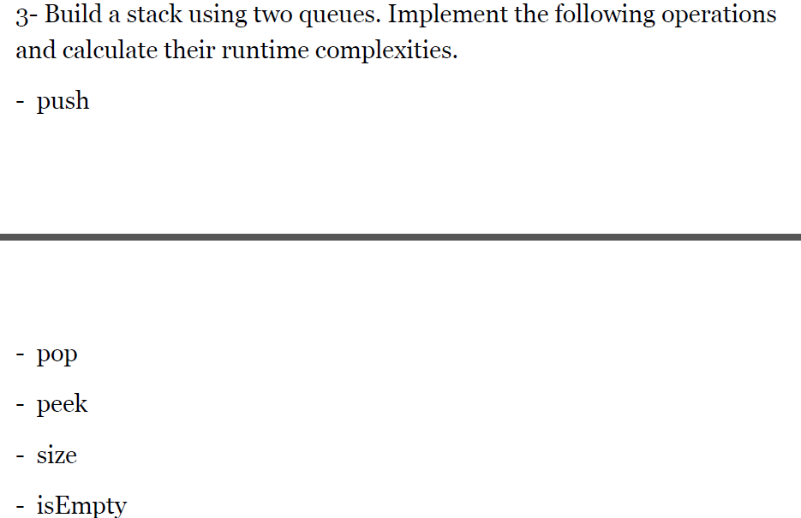

Ans:- We can implement Stacks using two queues. One is with making push operation heavy and another with making pop operation heavy.

Process -1 :- (Making Push Operation Heavy)

Conditions:-

a) Always pop from q1.

b) Any new item will always push to q2.

c) Push items (that remove from q1) to q2. [q2.add(q1.remove());]

d) Then exchange the queue.



The following four conditions should be followed strictly to make queues work like stack. Simulations and code is given below:-



**Q1**



**push(8);**



**Q2**



**push(5);**



**Q2**

**Q1**



Code:-

import java.util.LinkedList;  
import java.util.Queue;  
// video url :- https://youtu.be/XTouyMSE0Y8  
public class StackWithQueues {  
 private Queue<Integer> q1 = new LinkedList<>();  
 private Queue<Integer> q2 = new LinkedList<>();  
 private int size;

public void enqueue1(int item){// O(n)  
 q2.add(item);// always add items in q2 first  
 size++;// increment size for adding new items  
 // add all the datas from q1 to q2  
 while (!q1.isEmpty())  
 q2.add(q1.remove());  
 // swap the queues  
 Queue<Integer> temp = q1;  
 q1 = q2;  
 q2 = temp;  
 }  
 public int dequeue1(){  
 if(isEmpty()) throw new IllegalArgumentException();

size--;   
 return q1.remove();  
 }  
 public int size(){  
 return size;  
 }  
 public int peek1(){  
 return q1.peek();  
 }  
 private boolean isEmpty(){  
 return (q1.isEmpty() && q2.isEmpty());  
 }  
   
 public static void main(String[] args) {  
 StackWithQueues s1 = new StackWithQueues();  
 s1.enqueue1(10);  
 s1.enqueue1(20);  
 s1.enqueue1(30);  
 System.*out*.println(s1.dequeue1());  
 System.*out*.println(s1.dequeue1());  
 System.*out*.println(s1.dequeue1());  
 // System.out.println(s1.dequeue1());  
 }  
}